**Self Driving Car Simulation**

MINOR PROJECT REPORT

By

**T.S Kaviyashruthi (RA2111026010405)**

**Sneha Jana (RA2111026010363)**

**Prithvi Pandaala (RA2111026010364)**

Under the guidance of

**DR. KARPAGAM M**

*In partial fulfilment for the Course*

of

**18CSC305J- ARTIFICIAL INTELLIGENCE** in CINTEL



**FACULTY OF ENGINEERING AND TECHNOLOGY**

**SCHOOL OF COMPUTING**

**SRM INSTITUTE OF SCIENCE AND TECHNOLOGY**

**KATTANKULATHUR**

**NOVEMBER 2023**

**SRM INSTITUTE OF SCIENCE AND TECHNOLOGY**

**(Under Section 3 of UGC Act, 1956)**

**BONAFIDE CERTIFICATE**

Certified that this minor project report for the course **18CSC305J- ARTIFICIAL**

**INTELLIGENCE** entitled in " **Self Driving Car Simulation**" is the bonafide work of

**T.S Kaviyashruthi (RA2111026010405), Sneha Jana (RA2111026010363) and Prithvi Pandaala (RA2111026010364)** who carried out the work under my supervision.

### SIGNATURE SIGNATURE

Dr. Karpagam M Dr. R. Annie Uthra

**Assistant Professor, Head of Department**

**Department of Computational Intelligence Department of Computational Intelligence,**

SRM Institute of Science and Technology SRM Institute of Science and Technology,

Kattankulathur Kattankulathur

### ABSTRACT

In response to the escalating challenge of fake news dissemination in today's digital sphere, this project leverages Natural Language Processing (NLP) techniques to develop a robust detection system. Utilizing a comprehensive dataset sourced from Kaggle, the project aims to create a reliable tool for identifying and combatting misinformation. This dataset, renowned for its diversity and quality, provides a solid foundation for training and evaluating the effectiveness of the proposed algorithms. Key objectives include optimizing accuracy while minimizing false positives to ensure the preservation of authentic content integrity. Preprocessing steps encompass rigorous data cleaning and NLP feature extraction, facilitating comprehensive analysis and classification. Vectorization is achieved through Count Vectorizer, enabling efficient representation of textual information. Through the utilization of Pipeline and Grid Search methodologies, multiple classification algorithms are meticulously evaluated to identify the most effective approach. Challenges such as distinguishing satire from false information, handling ambiguous language and context, and scaling to large volumes of data are addressed with strategic algorithmic enhancements. The findings of this project contribute to the broader discourse on combatting fake news, offering insights and methodologies essential for developing advanced algorithms capable of discerning factual information from misinformation in the digital landscape.

### ACKNOWLEDGEMENT

We express our heartfelt thanks to our honorable **Vice Chancellor Dr. C.**

**MUTHAMIZHCHELVAN**, for being the beacon in all our endeavors.

We would like to express my warmth of gratitude to our **Registrar Dr. S.**

**Ponnusamy,** for his encouragement.

We express our profound gratitude to our **Dean (College of Engineering**

**and Technology) Dr. T. V.Gopal,** for bringing out novelty in all executions.

We would like to express my heartfelt thanks to Chairperson, School of Computing **Dr. Revathi Venkataraman,** for imparting confidence to complete my course project

We wish to express my sincere thanks to **Course Audit Professors Dr.**

**Lakshmi. C, Professor, Department of Computational Intelligence** and **Course Coordinators** for their constant encouragement and support.

We are highly thankful to our Course project Faculty **Dr. Karpagam M, Assistant Professor, Department of Computational Intelligence,** for herassistance, timely suggestion and guidance throughout the duration of this course project.

We extend my gratitude to our **HOD Dr. R. Annie Uthra ,Department of Computational Intelligence** and my Departmental colleagues for their Support.

Finally, we thank our parents and friends near and dear ones who directly and

indirectly contributed to the successful completion of our project. Above all, I thank the almighty for showering his blessings on me to complete my Course project.

**TABLE OF CONTENTS**

# CHAPTER CONTENTS

1. **INTRODUCTION**
2. **Literature Survey**
3. **Implementation requirements**
4. **Simulation based implementation**
5. **Input**
6. **OUTPUT**
7. **Results**
8. **CONCLUSION**
9. **REFERENCES**

Chapter 1 : Introduction

The idea of self-driving vehicles dates back much further than Google’s research in the present day. In fact, the concept of an autonomous car dates back to Futurama, an exhibit at the 1939 New York World’s Fair. General Motors created the exhibit to display its vision of what the world would look like in 20 years, and this vision included an automated highway system that would guide self-driving cars. While a world filled with robotic vehicles isn’t yet a reality, cars today do contain many autonomous features, such as assisted parking and braking systems. Meanwhile, work on full-fledged autonomous vehicles continues, with the goal of making driving a car safer and simpler in the coming decades.

## 1.1 History

Experiments have been conducted on automated driving systems since at least the 1920s; trials began in the 1950s. First experiment conducted in the USA, 1920. Carnegie Mellon researcher first presented a research paper for autonomous vehicles using the neural networks. By 1958, General Motors had made their futuristic vision into a reality. The car’s front side was embedded with sensors called pick-up coils which could detect the current flowing through a wire embedded in the road. The current could be manipulated in order to move the steering wheel left or right. The first semi-automated car was manufactured in 1977, by Japan's Tsukuba Mechanical Engineering Laboratory, which required specially marked lanes that were interpreted by two cameras on the vehicle and an analog computer.[54] A landmark autonomous car introduced in the 1980s, with Carnegie Mellon University's Navlab and ALV projects funded by the United States' Defense Advanced Research Projects Agency (DARPA) starting in 1984 and Mercedes-Benz and Bundeswehr University Munich's EUREKA Prometheus Project in 1987.[54] From the 1960s through the second DARPA Grand Challenge in 2005, boosted vehicle research in the United States was primarily funded by DARPA, the US Army, and the US Navy, yielding incremental advances in speeds, driving competence in more complex scenarios, control and sensor systems. Companies and research organizations have developed prototypes. [54] By 2013, many famous companies including BMW, Audi, Cruse, Ford, and Mercedes Benz were all working on their own self driving vehicle. Tesla autopilot-2015 is the most significant example of the semi-autonomous vehicle and it succeeds on the road. Autopilot mode enabled hands-free control system for highway and freeway driving. [37] Tesla Autopilot is a collection of advanced driver-assistance system features offered by Tesla that has lane keeping, adaptive cruise control, self-parking, accurate lane changes, semiautonomous navigation on limited access freeways, and the ability to summon the car from a garage or parking area. Although in all of these conditions, the driver is responsible and the car requires constant supervision. The company claims that these features reduce accidents caused by driver negligence and fatigue from long-term driving.[55] In 2017, Audi stated that its latest A8 car would be automated at speeds of up to 60 kilometres per hour using its own "Audi AI". The driver would not have to do safety checks such as frequently checking the steering wheel. The Audi A8 was claimed to be the first consumer grade production car to reach Level 3 automated driving, and Audi would be the first manufacturer to use lidar scanners in addition to cameras and ultrasonic sensors for their system.[54] In November 2017, Waymo announced that it had begun testing self driving cars without a safety driver in the driver position; although, there was still an employee in the car. In October 2018, Waymo announced that its test vehicles had traveled in autonomous mode for over 10,000,000 miles (16,000,000 km), increasing by about 1,000,000 miles per month. In December 2018, Waymo was the first company to commercialize a fully autonomous taxi service in the US, in Phoenix, Arizona.[54].

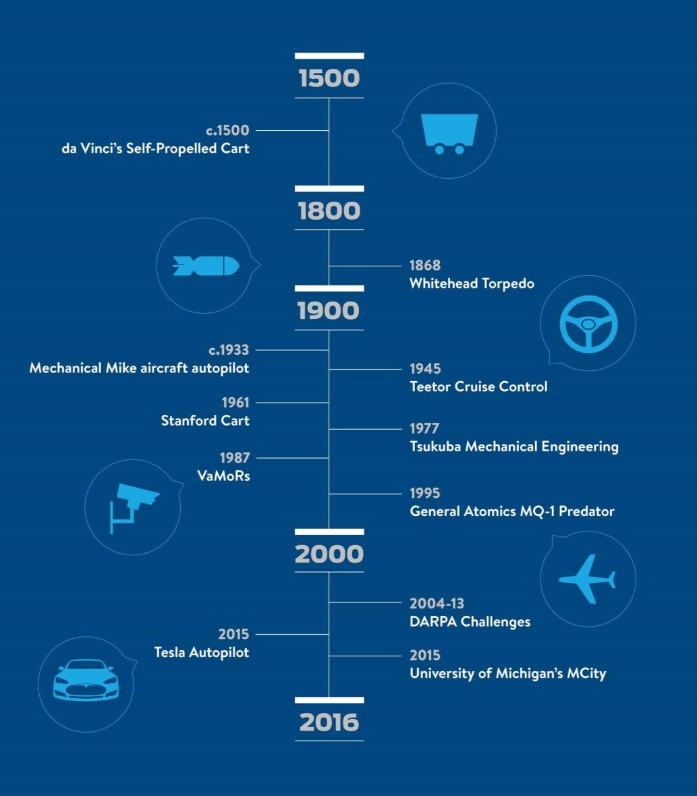

Fig. 1.1 Evolution of Autonomous Vehicles (Till 2016) [57]

## 1.2 Levels of Autonomy [56]

Self-driving cars are referenced in “self-driving levels” as defined by the SAE International, which can be viewed below:

**Level 1** automation some small steering or acceleration tasks are performed by the car without human intervention, but everything else is fully under human control

**Level 2** automation is like advance cruise control or original autopilot system on some Tesla vehicles, the car can automatically take safety actions but the driver needs to stay alert at the wheel

**Level 3** automation still requires a human driver, but the human is able to put some “safety-critical functions” to the vehicle, under certain traffic or environmental conditions. This poses some potential dangers as humans pass the major tasks of driving to or from the car itself, which is why some car companies (Ford included) are interested in jumping directly to level 4

**Level 4** automation is a car that can drive itself almost all the time without any human input, but might be programmed not to drive in unmapped areas or during severe weather. This is a car you could sleep in. This is the reason why this project is titled as “L4 – Self Driving Car”.

**Level 5** automation means full automation in all conditions

## 1.3 Motivation

In a country like India, accident is a major problem which must be solved using new technologies rather than traditional ways.

Indian commuters travel approximately 35 km/day, out of that 75% commute using private vehicles. If the average speed is around 60 km/h then every person spends 30 minutes per day travelling. One crore people travel per day so people spend approximately 570 years in driving per day. This is too much time spent on just driving.

77.3% accidents caused because of Human error (2018). One-fourth of the Indian drivers use phones while driving which is dangerous for everybody (survey 2015).

## 1.4 Objectives

By using a combination of image processing, object detection, waypoint algorithm and sensor data, this system aims at creating a fully self-driving car which is capable of driving on a road with other vehicles and objects. The car would analyze the video feed, perform tasks such as object detection, lane detection and would make a decision regarding the parameters like throttle, brake, steer in order to drive the car on a road.

Our primary priorities are as follows:

* Safety
* Save human time
* Follow Rules
* Better transportation service
* Less traffic
* To make life better

## 1.5 Project Modules

❑ Controller Design

❑ Object detection

❑ Traffic sign detection and recognition

❑ Path planning

❑ Sensor fusion

❑ Path Planning

❑ Lane Detection

❑ Deployment on the Raspberry Pi

## 1.7 Applications

* Street View for Google Maps
* Food delivery
* Transportation
* Goods delivery
* Surveillance

## 1.8 Advantages

* Safety; reduce accidents rate.
* Machines stick to the rules
* Speed - Save time
* Frictionless transport, no congestion
* New balances of public spaces; perhaps even road trains and intelligent routing to augment or replacement of public transport
* Improves health quality
* More Luxury

## 1.9 Disadvantages

* Expensive (Requires powerful architecture)
* Hackers can change route
* Failure of sensor, vehicle can create chances of accident
* Threat to user privacy
* Requires detailed testing on complex situation

# Chapter 2 Literature Review

## 2.1 Auto Encoders

Autoencoders are a type of neural network that tries to mimic its input data as closely as possible to its output. Its aim is to take an input, transform it into a compressed representation called code or embedding. Then, this code or embedding is converted back into the original input. The code is also called the latent-space representation.

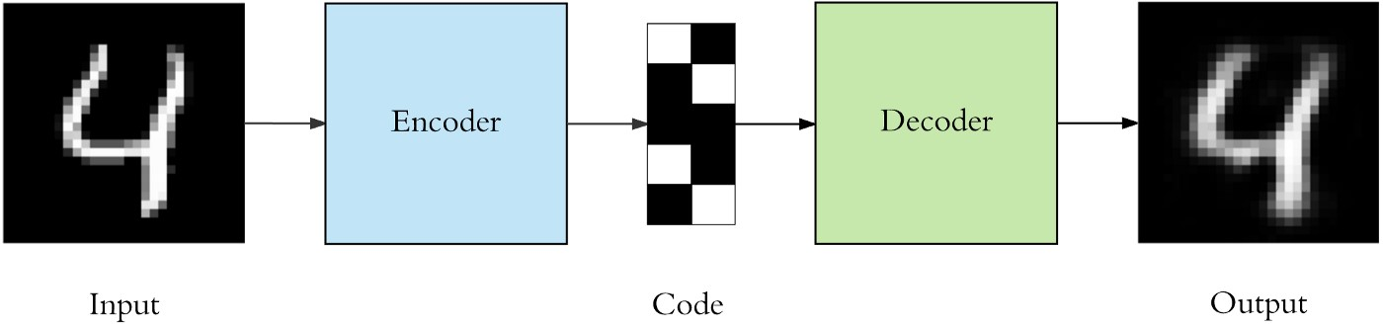

Fig. 2.1Auto Encoder Block Diagram [59]

As a formal definition, an autoencoders represents a nonlinear relationship of an input to an output through an intermediate representation called code or embedding.

It can be used to learn the data representation or representation space efficiently in an unsupervised manner. The main purpose is to learn a compressed representation of the input data.

Some of the key things to know about the autoencoders are:

* **Data-specific compression**: Autoencoders compresses the data that is same to what it had been trained on. An autoencoder trained on cat photos cannot compress other animal faces photos easily.
* **Unsupervised**: Training an autoencoder is a very easy task as we don’t need labelled data. It can be easily trained on any kind of input data.
* **Lossy in nature**: There is always some difference between the input and output of the autoencoder. The output will always have some missing information in it.

As we know in unsupervised learning, the neural networks are trained using the unlabelled data, which allows them to find certain structure and patterns within data. This structure and pattern help the neural network to learn critical features from the data. These learnt features are then useful in training the other deep learning model pipelines, which improves their performance.

### 2.1.1 Architecture of Autoencoders

An autoencoder consists of three primary components:

1. Encoder
2. Code or Embedding 3. Decoder

The encoder reduces the given input into a fixed dimension embedding and the decoder converts that code or embedding the same as the original input data. The architecture of decoder is the mirror image of an encoder.

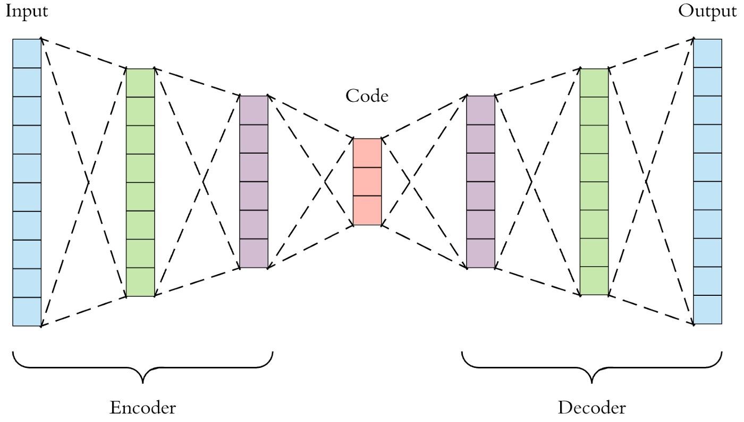

Fig. 2.2 Example Architecture [59]

While constructing an autoencoder, we make sure that the autoencoder does not memorize all the information. Instead, it should be able to prioritize which information should be learned as features, which information should not be considered. For this we can adapt following ways:

* Reducing the number of units or nodes in the layers (reduction in size of each layer).
* Adding some random noise to the input images.
* To increase randomness we can add some regularization.

### 2.1.2 Recommended Hyper Parameters for Autoencoders [59]

**Number of layers:** we can have as many layers in the encoder and decoder as we require. We can also choose how many nodes or units you want in our layers. Generally, the number of nodes decreases as we increase the number of layers in the encoder and vice-versa for the decoder.

**Number of nodes in the code layer:** It is better to have less number of nodes in this layer as compared to input size. Smaller size of code layer results into better compression results.

**Loss:** For the loss function, we usually use Mean Squared Error or Binary Cross Entropy.

### 2.1.3 Types of Autoencoders

There are different types of autoencoder starting from simple to denoising autoencoders used for various usecases.

* Vanilla Autoencoder
* Deep autoencoder
* Convolutional autoencoder
* Denoising autoencoder
* Variational autoencoder

#### Vanilla Autoencoder

A vanilla autoencoder is the most simplest form of autoencoder, also called simple autoencoder. It contains only one hidden layer between the input and the output layer, due to that it results in degraded performance compared to other counterparts.

#### Deep Autoencoder

In deep autoencoder, we do not restrict ourselves to only one layer which enables us to increase the accuracy of the autoencoder and it also helps us in tuning. In deep autoencoders, both the encoder and decoder consists of mirrored deep neural networks.

#### Convolutional Autoencoder

Both the vanilla and deep autoencoder uses dense layers to build the model. To work with both these autoencoders we need to modify input data which in turn results into loss of spatial information. Convolutional layers can use input data like images without any modification.

The convolutional autoencoder uses convolutional, relu and pooling layers in the encoder. In the decoder model, the pooling layer is replaced by the CovolutionTranspose layer for increasing the dimensions of the feature maps.

#### Denoising Autoencoder

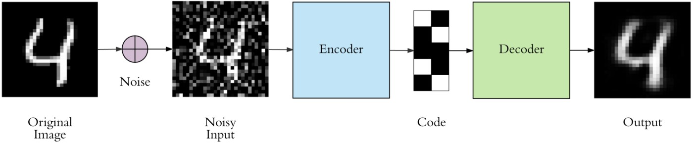

Fig. 2.3 Denoising Autoencoder [59]

Denoising autoencoder adds random noise to the original input data creating a corrupted version of the it. Adding noise makes the autoencoder robust to noise in the input image. The corrupt images are given to the autoencoder as input and then the autoencoder tries to rebuild the original undistorted image. It forces the autoencoder to get rid of rot learning.

#### Variational Autoencoder

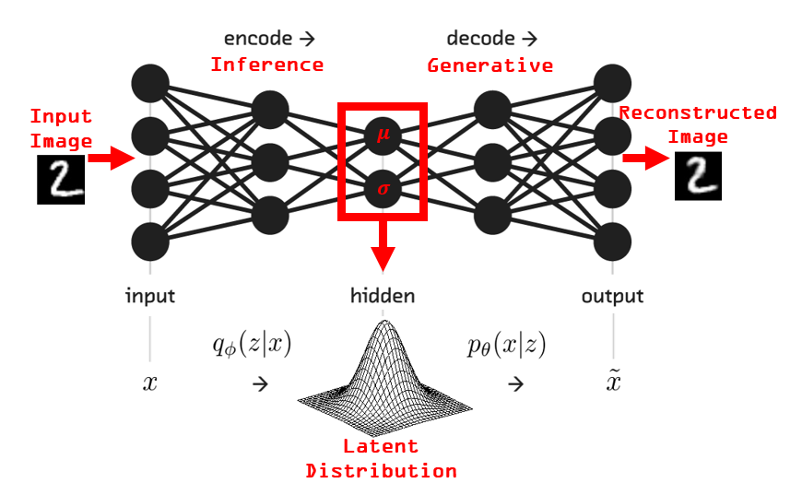

Fig. 2.4 Variational Autoencoder [60]

In variational autoencoders , code or latent spaces are continuous allowing us easy random sampling and interpolation.

In this model, the encoder outputs two vectors, one for the mean and another for the standard deviation which is used to describe latent state attributes. These two vectors are combined to get a encoding sample passed to the decoder which tries to reconstruct original input.

The variational autoencoder is a pretty powerful generative model as compared to other types. They have use cases ranging from generating fake faces to synthesizing music.

### 2.1.4 Applications of Autoencoder

* Dimensionality reduction
* Information retrieval
* Data compression
* Clustering
* Generating new examples

In our project we have used convolution autoencoder to encode images from different angles and these encodings are used to generate top view of the image which is discussed in section 4.4.

## 2.2 Convolutional Neural Network for Controllers

Most of the projects use some variation of a Convolutional Neural Network for image data.

A Convolutional Neural Network is a Deep Learning algorithm which can take in an input image, applies learnable weights and biases to various properties in the image and be able to differentiate one from the other. The pre-processing required in a Convolutional Network is much lower as compared to other algorithms. While in primitive methods filters are hand-engineered, but with enough training, ConvNets have the ability to learn these characteristics [7].

The architecture of a ConvNet is similar to that of the connectivity pattern of Neurons in the Human Brain and was inspired by the arrangement of the Visual Cortex. Individual neurons respond to stimuli only in a restricted area of the visual field which is known as the Receptive Field. A collection of such fields overlap with each other to cover the entire visual area.

### 2.2.1 Why ConvNets over Feed-Forward Neural Nets? [49]

An image is nothing but a matrix of pixel values, So we can just flatten the image (e.g. 6x6 image matrix into a 36x1 vector) and feed it to a Multi-Level Perceptron (consisting only dense layers) for classification purposes? But it is not the case.

In cases of extremely basic binary images, the method might show a satisfactory precision score while performing prediction but would have little to very less accuracy when it comes to complex images having pixel dependencies throughout the image.

A ConvNet is able to  **capture the Spatial and Temporal dependencies successfully** in an image through the application of relevant filters. The architecture fits better to the image dataset due to the reduction in the number of parameters and reusability of weights. In other words, this type of network can be trained to understand the sophistication of the image in a more precise way.

### 2.2.2 Network Architecture [50]:

One of the papers studied used the following network architecture.

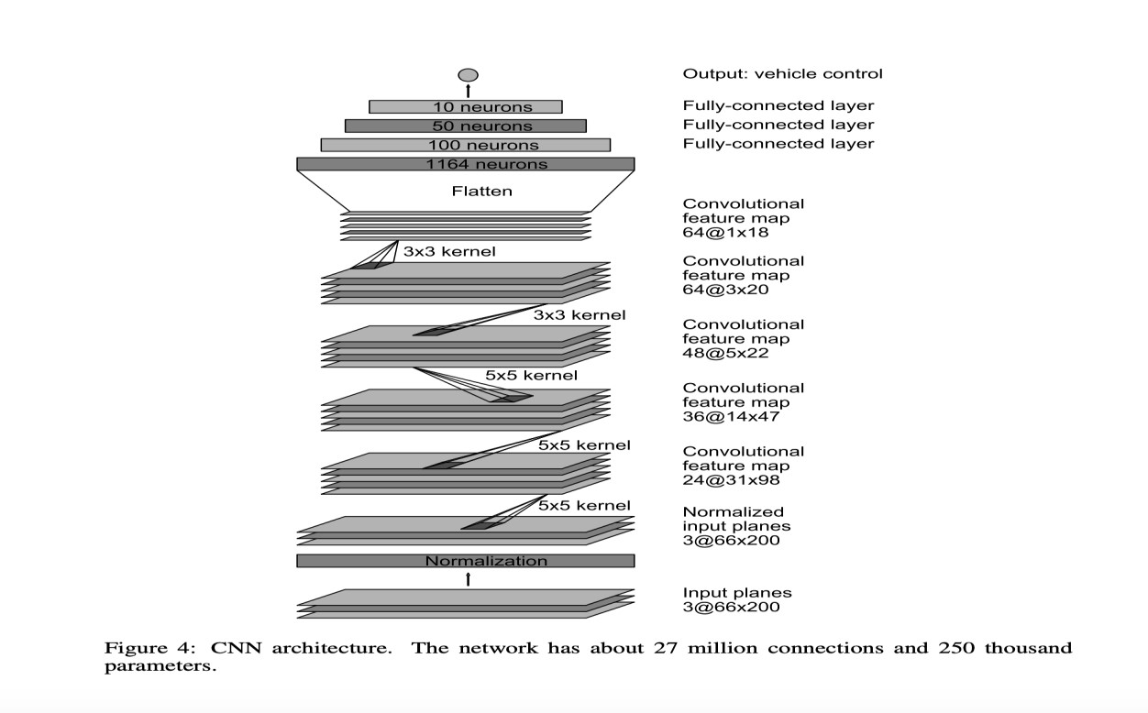

Fig. 2.5 Example Controller Architecture [47]

The output of such a network will be the vehicle control parameters, such as throttle, steer etc. This approach does not require the use of a controller.

# Chapter 3 : System Analysis and Design

This project requires many prebuilt libraries and dedicated hardware for real time computation. All the used libraries and hardware's details mentioned in this section.

## 

## 3.1 Implementation Requirements

### 3.1.1 Library Used

1. Python 3.6.4:

As Python is the most popular programming language used by software engineers, analysts, data scientists, and machine learning engineers alike, we have chosen python as our primary programming language for this project. In addition to that it also supports certain powerful libraries for designing neural networks and performing image processing.

1. SciPy :

SciPy is a free and open-source Python library which is used for scientific computing and technical computing. We have used Scipy for spline interpolation as it uses piecewise interpolation which better than conventional polynomial interpolation. 3) TensorFlow 2.0.0:

TensorFlow is an end-to-end open source platform for machine learning. It has a comprehensive, flexible ecosystem of tools, libraries and community resources that lets researchers push the state-of-the-art in ML and developers easily build and deploy ML powered applications. Build and train ML models easily using intuitive high-level APIs like Keras with eager execution, which makes for immediate model iteration and easy debugging. Easily train and deploy models in the cloud, on-pram, in the browser, or on-device no matter what language you use. A simple and flexible architecture to take new ideas from concept to code, to state-of-the-art models, and to publication faster.[[18]](https://www.tensorflow.org/) Machine learning researchers use the low-level APIs to create and explore new machine learning algorithms. In this class, you will use a high-level API named tf.keras to define and train machine learning models and to make predictions. tf.keras is the TensorFlow variant of the open-source Keras API.[[19]](https://developers.google.com/machine-learning/crash-course/first-steps-with-tensorflow/toolkit) 4) Pillow:

Pillow is a fork of Python Image Library which is maintained by Alex Clark and Contributors. It is a better and more friendlier version of PIL. It has support for opening, manipulating, and saving many different image file formats.

1. Keras: [[14]](https://keras.io/)

Keras is a high level API designed for human beings, not machines. Keras follows best approach for reducing cognitive load: it offers consistent & simple APIs, it reduces the number of user actions required for common applications, and it provides clear & actionable error messages. It also has detailed documentation and developer guides. We have used Tensorflow 2.0 as a backed for Keras.

1. Matplotlib:

Matplotlib is one of the plotting library for the Python programming language and its numerical mathematics extension NumPy.

1. Open-CV:

OpenCV is a library of programming functions primarily aimed at real-time computer vision. It was originally developed by Intel and later supported by Willow Garage then Itseez. This library is used in simulation and also in image transformation. OpenCV displays images in real-time so that users can see all deleted objects, lane and Traffic signs. Opencv also helped in non max suppression after the model detection.

**Google Cloud Platform:**

Google Cloud is a collection of Cloud Computing services offered by Google. The platform provides various services like compute, storage, networking, Big Data, Deep learning and many more that run on the same infrastructure that Google utilizes internally for its end users like Google Search and YouTube. Google server hasn’t gone down in years. So, if you are planning to run your application on the Google Cloud infrastructure, then you can be assured of your applications being safe and secure.[[21]](https://intellipaat.com/blog/what-is-google-cloud/) Google Cloud gives $300 credits to new users and these credits can be used to buy GPUs and CPUs.

## 3.2 UML Diagram

Unified Modeling Language is popular in the market because it is easy to understand. This is part of software engineering. Developer gets better idea about the system.

### 3.2.1 Use Case Diagram

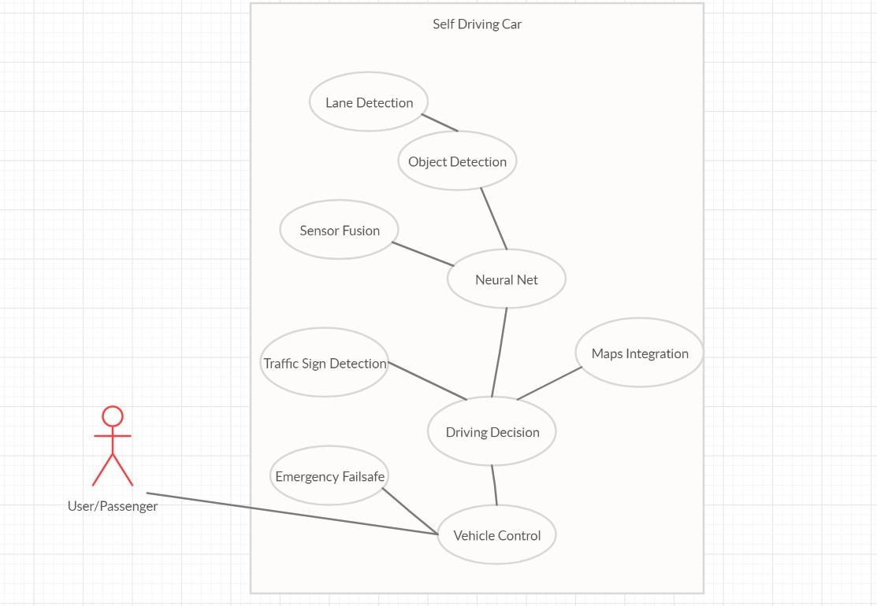

Fig. 3.5 Activity Diagram

### 3.2.2 Data Flow Diagram

###### 3.2.2.1 Context Level (level-0) DFD

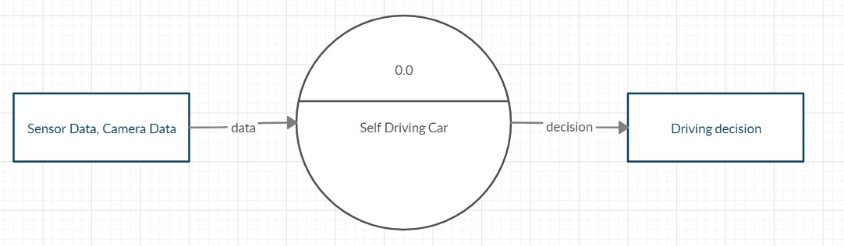

Fig. 3.6 Level-0 DFD

### 3.2.3 Sequence Diagram

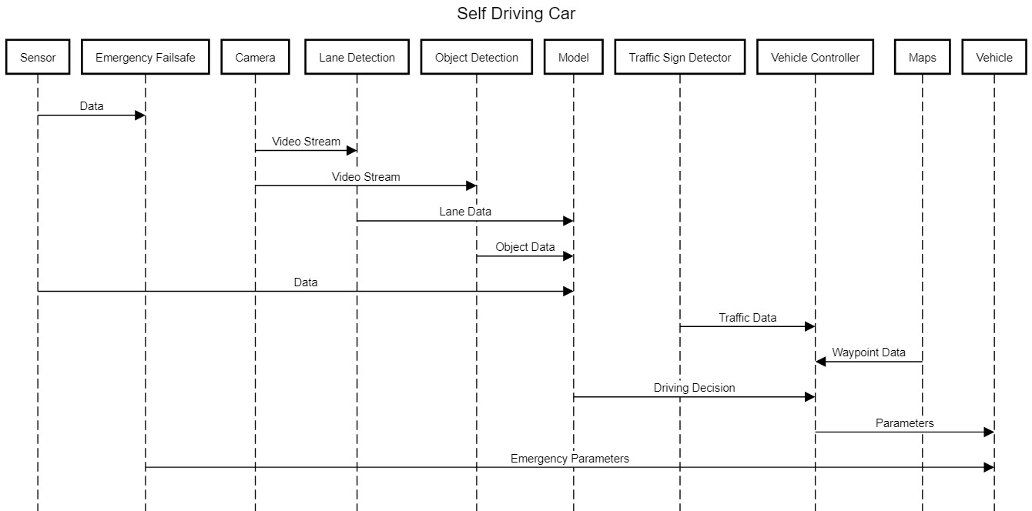

Fig. 3.8 Sequence Diagram

### 3.2.4 State Diagram

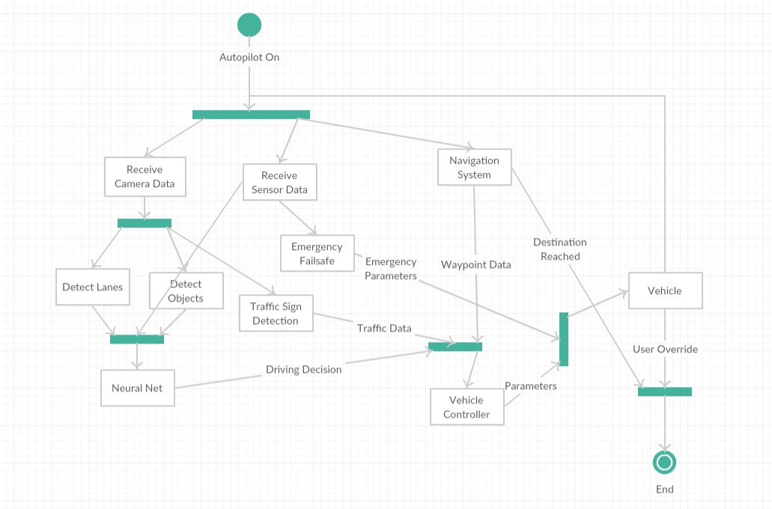

Fig. 3.9 State Diagram

# Chapter 4 : Simulator Based Implementation

To begin, Let’s take a look at different subsystems of self-driving car:

Sensors

•

Camera

•

GPS

•

Others

Perception

•

Object Detection

•

Traffic Sign

Detection

•

Object Tracking

•

Localization

Planning

•

Route Planning

•

Trajectory

Prediction

•

Behaviour

Planning

Control

•

PID

•

MPC

•

Others

Fig. 4.1 Functional Layers of Self Driving Car

**Sensors** : Various sensors can be used to perceive information of surrounding environment such as Camera, Lidar, Radar etc.

**Perception**: This is responsible for merging data from sensors and perform tasks like object detection, object tracking and localization.

**Planning**: coordinating layer that takes in all information from lower layers and decides future state to transition to along with the trajectory to adopt.

**Control**: responsible for moving the car and following a reference trajectory as closely as possible. This layer operates with the fastest time scale.

We have used Carla as our primary simulator for testing purpose because it has whole bunch of features which are needed in order to build an autonomous system.

To build a perfectly independent system we have adapted bottom up approach starting from making controller.

**Note:** I have designed DDPG, PID controller and Model predictive controller. As a use case of object detection I have derived aerial view from four different cameras which is used for object tracking. In addition to that our path planning strategy is also mentioned in following sections.

## 4.1 Motion Models

This section is divided into three parts. First part is about learning types. Second part is the dataset and lastly training.

### 4.1.1 Supervised Learning

###### 4.1.1.1 Udacity’s Dataset [58]

Humans learn in many ways like observing, experience, based on rewards and so on. Like humans, computers also learn accordingly. Supervised learning is student-teacher concepts; Supervisor observes the environment and based on action it will set weights of the neural network. Supervised learning refers to learning by training a model on labelled data. It is a very common approach for predicting an outcome. For example, let’s say we want to predict who is likely to open an email we send. We can use the data from past sends along with the “label” telling us if the recipient opened the email or not. From there, we can build a training data set with data points about the recipient (location, demographics, past email engagement behaviour) along with the label. Our model trains by trying many different ways to predict the label based on the other data points until it finds the best one. Now that model can be used to predict who will open the next email campaign we send.

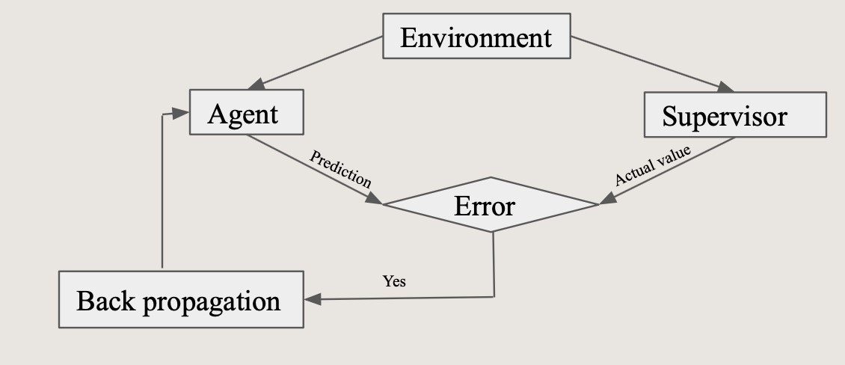

Fig. 4.2 Block diagram of Supervised Learning

4.1.1.1.1 Dataset Preparation

Udemy made a GUI for self-driving car simulation in Unity. We generated data using that Github repo. Data generation took one day because it worked with the images. The software provides two different tracks and one car. Someone can change paths in Unity. The vehicle had three cameras mounted on the top. The camera captures the images of the left side, center, and right side. Throttle value, steering angle, and velocity decided according to the car driving on the track. All the information has been stored in the CSV file. CSV file has image name, throttle value, steering angle, speed, and reverse. Throttle value changes between zero and one. Steering varies from -1 to 1. Here minus one means left side, zero means inline, one means turn right. Speed is in float, whereas reverse holds only true or false. We worked at a college for model development because they have a multicore CPU and GPUs. The model took two days in training. These models are used to predict throttle value and starring value. This model was simulated in Carla. Firstly, actors are created in Carla and then fixed sensors such as Collision detector, Cameras. Camera captures the image and feeds it to the Neural Network for prediction and based on the prediction the car moves in Carla’s environment.

Format:

Table 4.1 Training Dataset

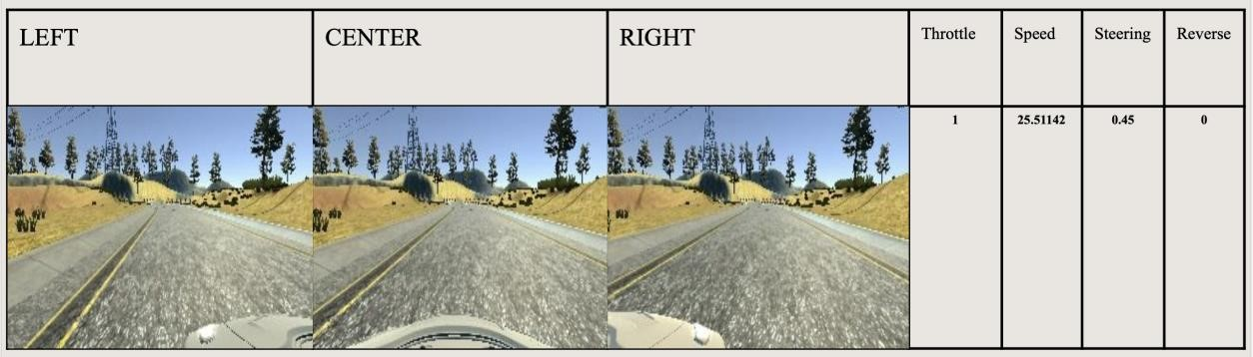

###### 4.1.1.2 Based on Carla’s Autopilot System

Imitation learning techniques aim to mimic human behaviour in a given task. An agent (a learning machine) is trained to perform a task from demonstrations by learning a mapping between observations and actions.

4.1.1.2.1 Dataset Collection

As learning examples, we collected wide range of driving sequences as episodes. In order to capture images, we mounted RGB camera on top of ego car which sends data in terms of bytes at every 0.2 seconds. Car’s state was recorded in terms throttle values (0.0 to 1.0) and steering values (-1.0 to 1.0). Each episode consisting of 3000 frames with corresponding state of car.

Sensors Used: RGB Camera (400*300 Resolution)

Table 4.2 Data Format

|  |  |  |
| --- | --- | --- |
| Property | Type | Values |
|  |  |  |
| Images | float | 0.0 to 1.0 |
| Throttle | float | 0.0 to 1.0 |
| Steering | float | -1.0 to 1.0 |

Dataset Optimization:

In our driving sequences we have observed that there were very few states where vehicle is trying to change its direction which in turn results into imbalance of dataset. As you can see below in the figure distribution of steering values is not uniform. So we have tried to rebalance our data by increasing rare samples of data. It was done by flipping and duplicating certain set of example which resulted into nice balanced set of examples.

Edit Title

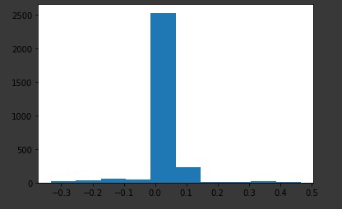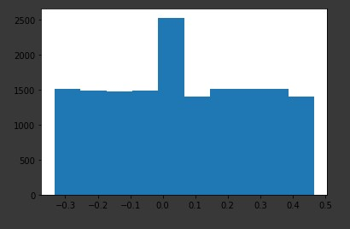

Fig. 4.3 Frequency Distribution of Steering Values Fig. 4.4 Frequency Distribution after rebalancing

If you can see in the above image number of examples are still higher for straight steering value (0.0). We have done this to still prioritize jerk free driving.

###### 4.1.1.3 Train and Test model

Model has three input images and one output. Based on the road situation, the model will decide speed, steering angle and break. The architecture for the model is the mansion below.

**Model Architecture:**

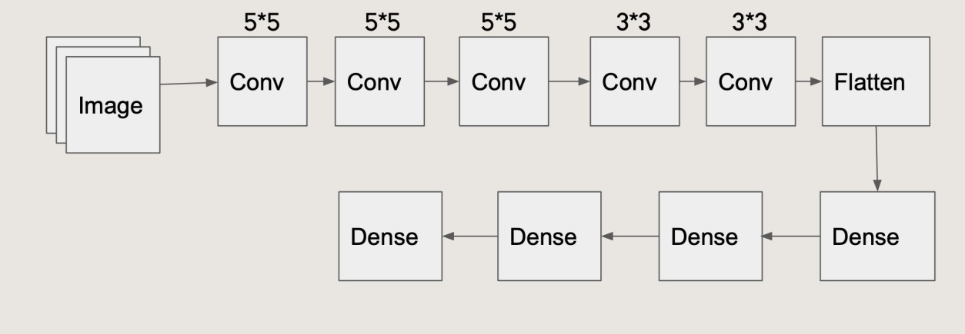

Fig. 4.3 Architecture **Test:**

Table 4.3 Test Results

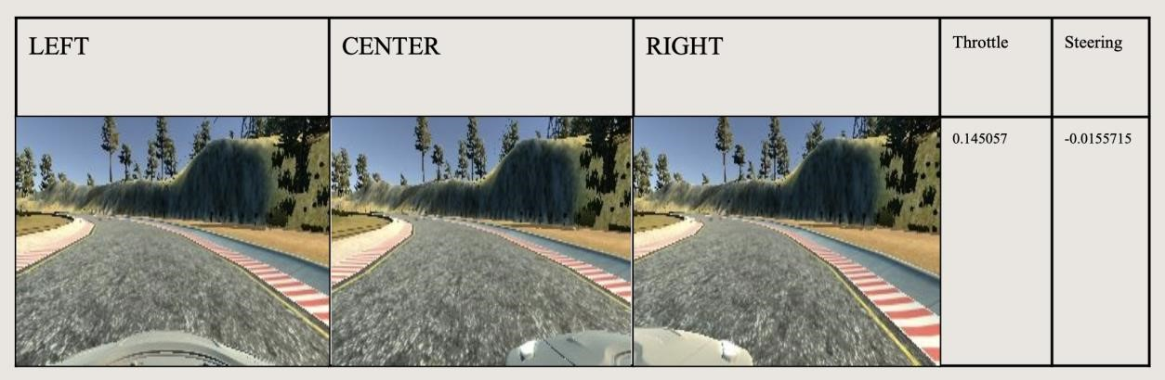

###### 4.1.1.4 Results: Merits and Demerits

It is quite simple solution but we need a lot of data and good network architecture.

Issues with this Approach:

* Expert Driving Sequences
* Noisy Outcomes
* No Control Over Controller (It’s just a Black Box)

## 4.2 Object Detection [58]

Object detection is useful in many applications for example self-driving. People have been working on this problem since 2002 and gradually they made accurate models. Still there is no model like the human eye but it will work in the real time. Obstacle detection is part of object detection and it is used in Robotics. In robotics distance of obstacles, also found using this method because this method is cheap.

### 4.2.2 Training

ImageNet dataset was used in YOLO training and a total of 1000 classes were there. Total 160 epochs were implemented on the data and learning rate was 0.1 with stochastic gradient descent. In the first phase of training, input image size was 224 × 224 and then it was re-tuned with 448× 448 images for 10 epochs at a high learning rate. End of the training, results were very good; top-1 accuracy was 76.5% and top-5 was 93.3%. Then the last two layers were removed for a detector. Yolo added a total four new layers in which first three were convocation and last one was convolution layer with 1024 filters with 125 output. Pass-through layer was added to the YOLO. Accuracy satisfies requirements.

### 4.2.3 Class Prediction

Generally, classifiers are mutually exclusive but in object detection outputs are not exclusive. Hence, Yolo applied a softmax at the end for finding probabilities of the detection. This algorithm finds multi- labels in the images with high precision. For example, the output labels may be “stop” and “men at work” which are not non-exclusive. In classification, mean square loss has good output but in YOLOv3 the same function cannot work so binary cross-entropy is used for prediction. This will reduce the calculation time.

## 4.3 Traffic Sign Detection and Recognition [58]

Every country has its own set of rules and regulations. There are many traffic rules in the world but the sign and its meaning is deferring according to the province. Traffic signs play an important role in driving so vehicles must be moved accordingly. Indian traffic rule book has above ninety traffic signs but we choose only 27 signs for this project.

### 4.3.1 Dataset

This is the first part of deep learning. Data labelling is the tedious and time-consuming part in the whole project. There is a lot of software available for labelling. The foremost challenging part of labelling was to find software that provides different colours for annotation. Initially, we thought MakeML software would work, but it has some limitations. The MakeML offers only four colours, which means anyone can have only four labels in software. Diffgram is the free online platform for the image annotation tool.

All-important labels are considered and listed below.

**Labels:**

No Entry, One-way, Prohibited both sides, Right side prohibited, Left side prohibited, Overtake

Prohibited, o parking, No stopping, head only, head or right, Ahead or left, School ahead, Parking, Hospital, Restriction ends, Men at work, Z-crossing, Sound Horn, Keep Left side, Keep right side, Turn right only, Bump, vehicle prohibited, Stop, Give away, U-turn prohibited.

HyperLabel is one of the best software for Machine Learning; it provides many functionalities. HyperLabel uses hex colour code, therefore the user can have 256*256*256 Labels. Each image annotated using a triangle type label. Polygon type labels tried in data labelling, but it became way more complicated, so the triangle used. Dark Side of HyperLabel, it crashed many times because of too many images which increased workload. The best part of it, the review section, where each image name displays with the label. At the end of this week, the data set was available in COCO, YOLO, Pascal VOC format. HyperLabel can also generate the JSON format dataset, but it was not useful in training.

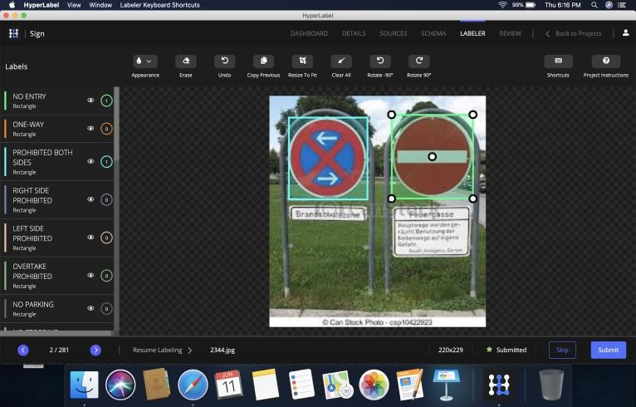

Fig. 4.13 HyperLabel Dataset Preparation

### 4.3.2 Transfer Learning

**Description:**

Training networks of this size is expensive, and even with a recent GPU it can take days to train a network. Luckily, transfer learning comes to the rescue! Convolutional networks normally consist of an input layer, a stack of convolutional layers and max pool layers (subsampling), a fully connected layer and the output layer. The convolutional layers are filters that are applied to the images, and they are basically the ones in charge of the feature extraction. The deeper in the network they are, the more specific is the extracted feature. The last layer is basically a classic network, and as we know, they can be less expensive to train. It is in charge of taking the output of the first part and classifying it. Transfer learning is a technique where we take a pre-trained network, remove the last part of the network (the classifier) and replace it with our own. Then we train our classifier. This allows us to use battle-proven architectures at a fraction of the cost. We used a yolo pre trained model in Training. The ImageAI library is very useful in transfer learning. Generally, 200 epochs give accurate models. Yolov3 does not contain a “Traffic signs” class. But we want to make our system such a dynamic that it must be able to detect traffic signs. So, we need to add various extra classes in YOLOv3 and hence we used transfer learning to add new classes to the YOLOv3.

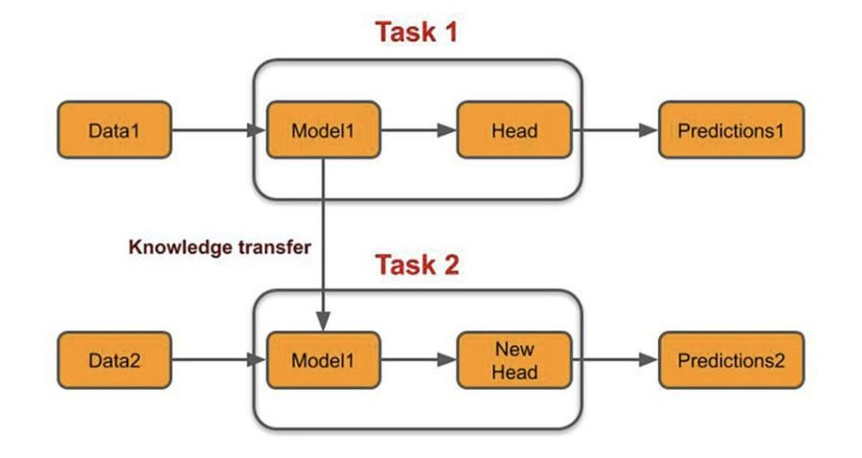

Fig. 4.14 Block Diagram of Transfer Learning

### 4.4.1 Purpose

A top-down view has a number of advantages:

* it condenses relevant information from four images into one.
* it can serve as a building block for localization/mapping algorithms.
* it can be used for path planning.
* it allows for training a higher-level reinforcement learning agent that chooses an optimal path rather than atomic actions.

### 4.4.2 Dataset Collection

We’ve trained the model on data gathered in the two default towns available in CARLA (Town02), 40 episodes, each episode 1000 frames long. For validation and testing we used separate episodes. All results shown here were produced on the test episodes.

We’ve gathered images with resolution 300 × 200 but because the training took a lot of time, we’ve decimated them by selecting every other row/column, and then cropped them so that the shape would be divisible by 8 (requirement of the fully convolutional autoencoder), so the final shape was 144 × 96.

To collect data, we set up a GCP instance with Tesla P100 and it took ~2.5 days to capture 40 episodes of each town in synchronous mode of CARLA.

### 4.4.3 Dataset Pre-processing

As a early bird in this world of self-driving cars, our initial approach was to train our neural network on rgb image. But it turns out as non-linear regression problem because network has to predict continuous value between 0.0 to 1.0.

We all know that deep learning approach is far more accurate in classifying things, so we thought that what if we classify each pixel in certain categories. Fortunately, In CARLA we have a camera sensor that can capture semantically segmented image from the world.

Due to some issues in previous models which we will discuss in subsequent section we have decided to settle down on predicting steering angle directly from the rgb image. Motivation behind predicting steering angle was NVIDIA model. As steering angles are numerical values it is a regression problem.

**Architecture:**

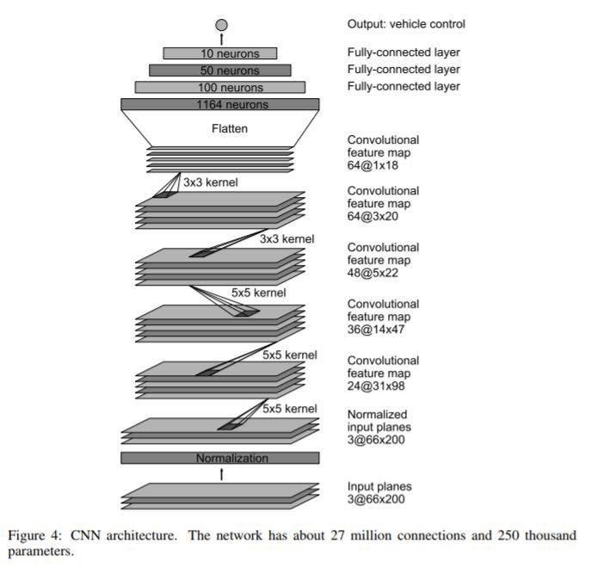

Fig. 5.25 Architecture of NVIDIA Model (Based on Paper) The above diagram is from Nvidia’s paper. It contains about 30 layers in total, not a very deep model by today’s standards. The input image to the model (bottom of the diagram) is a 66x200 pixel image, which is a pretty low-resolution image. The image is first normalized, then passed through 5 groups of convolutional layers, finally passed through 4 fully connected neural layers and arrived at a single output, which is the model predicted steering angle of the car. It uses Relu as an activation and mean squared error as loss function.

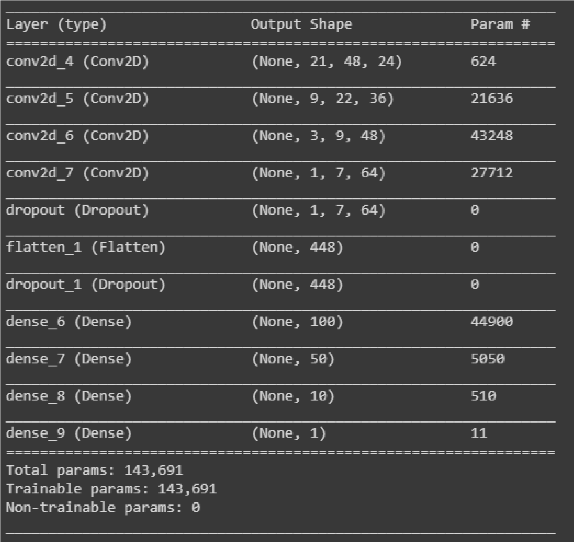

Fig. 5.26 Model III Summary

This model takes 200*36 image as input, so we have to resize our image.

At the end of 8 epochs loss was approximately 0.0907 which is significantly low.

**5.INPUT**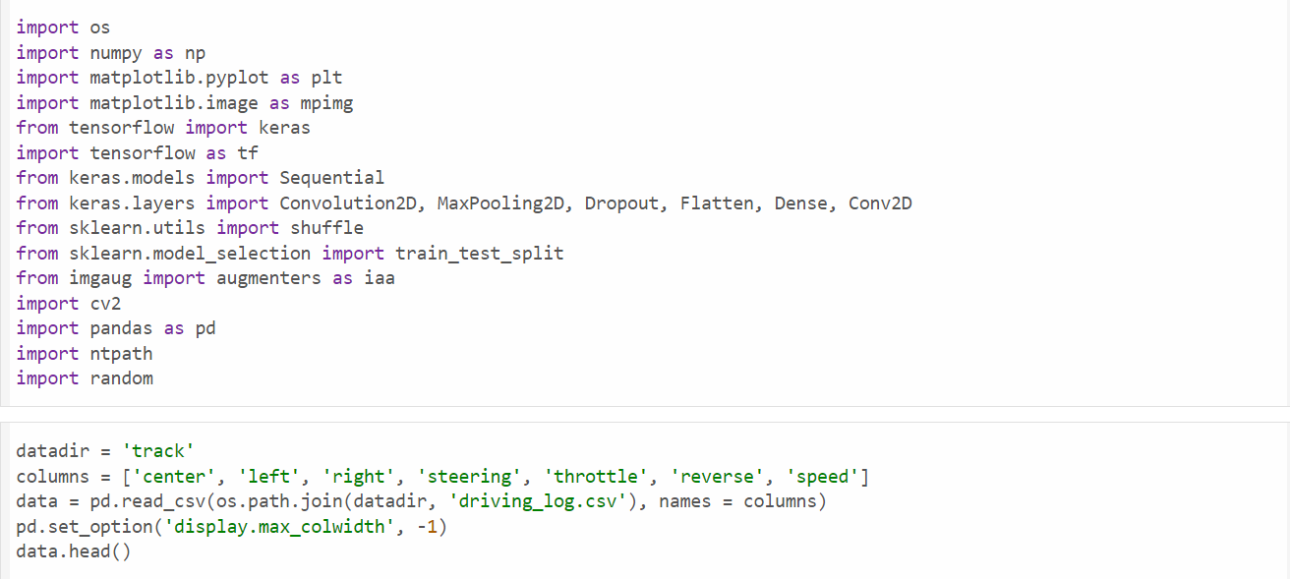

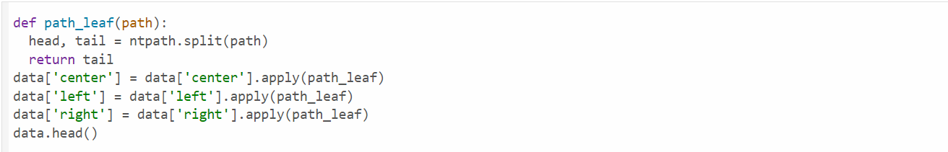

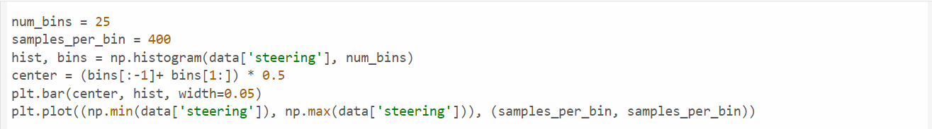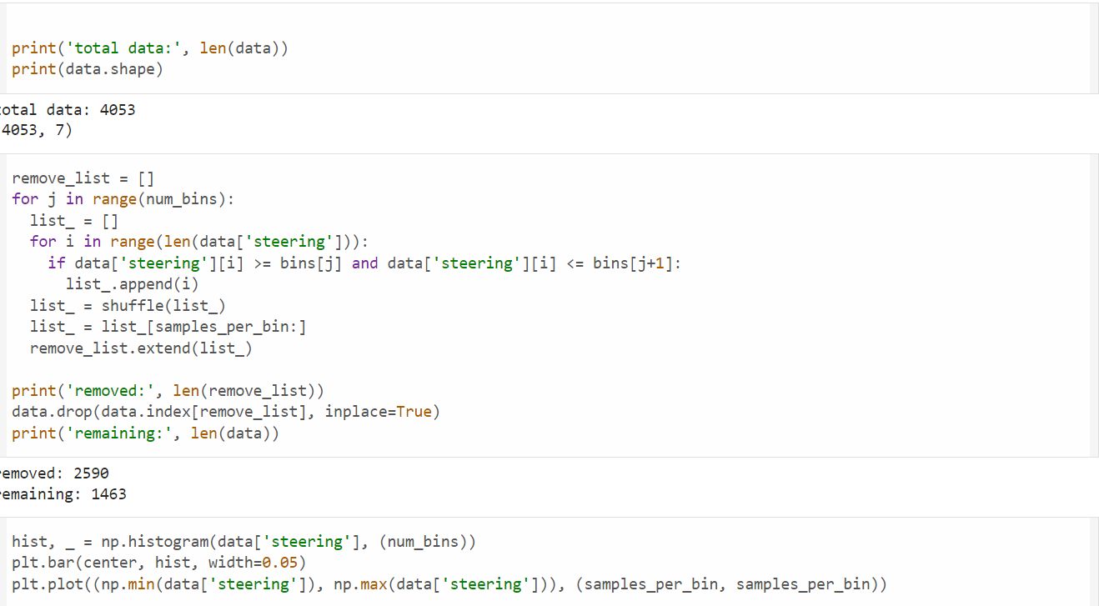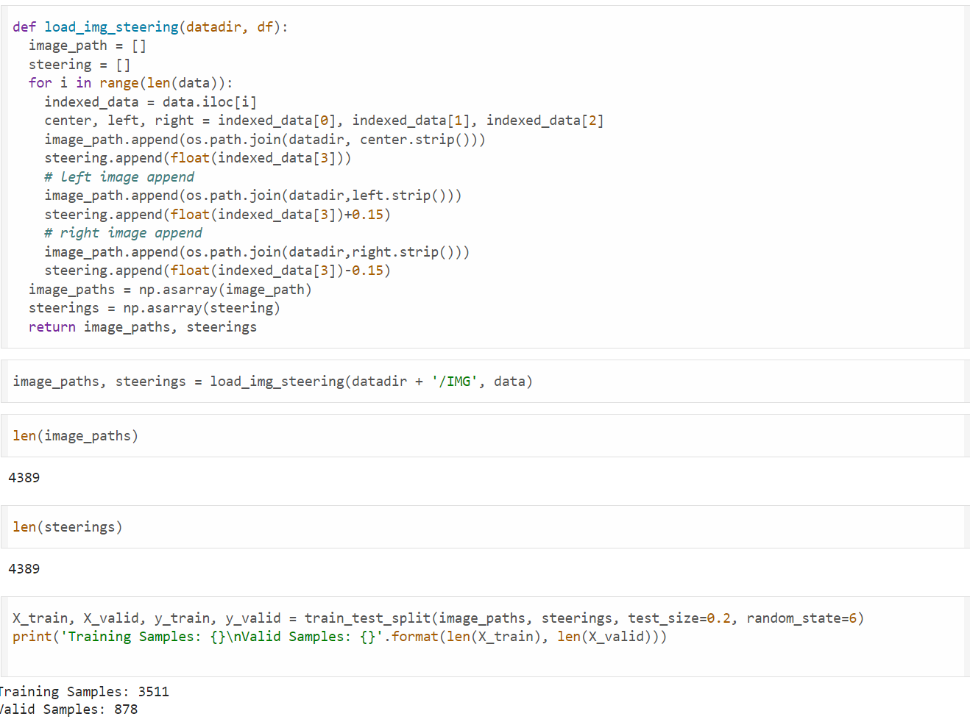

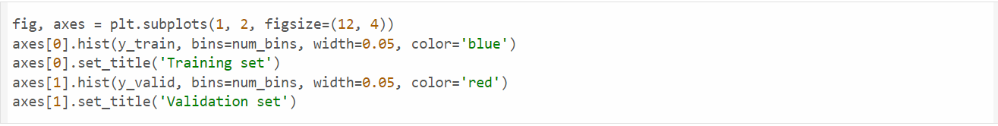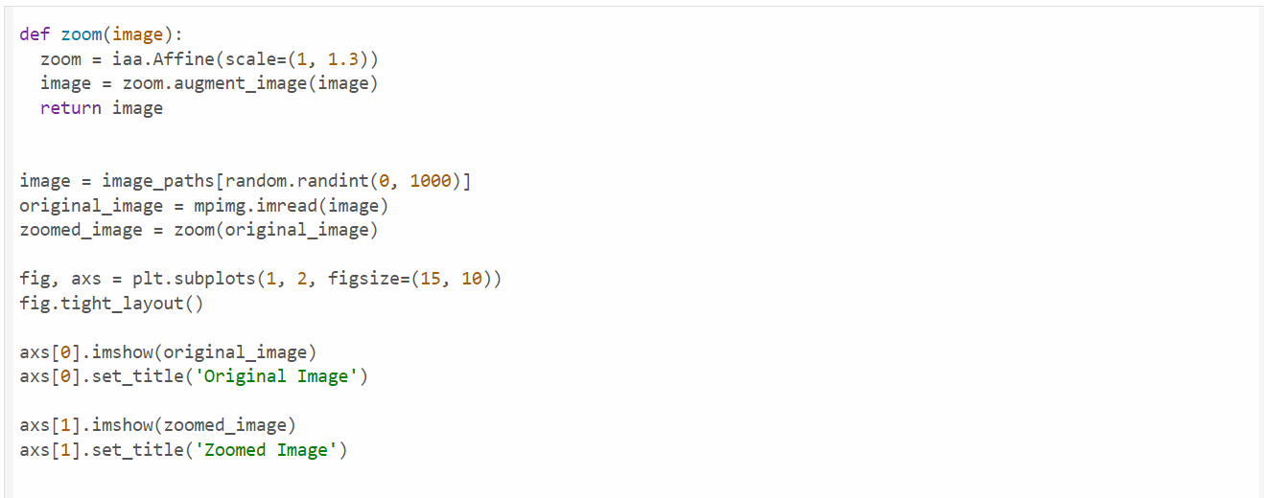

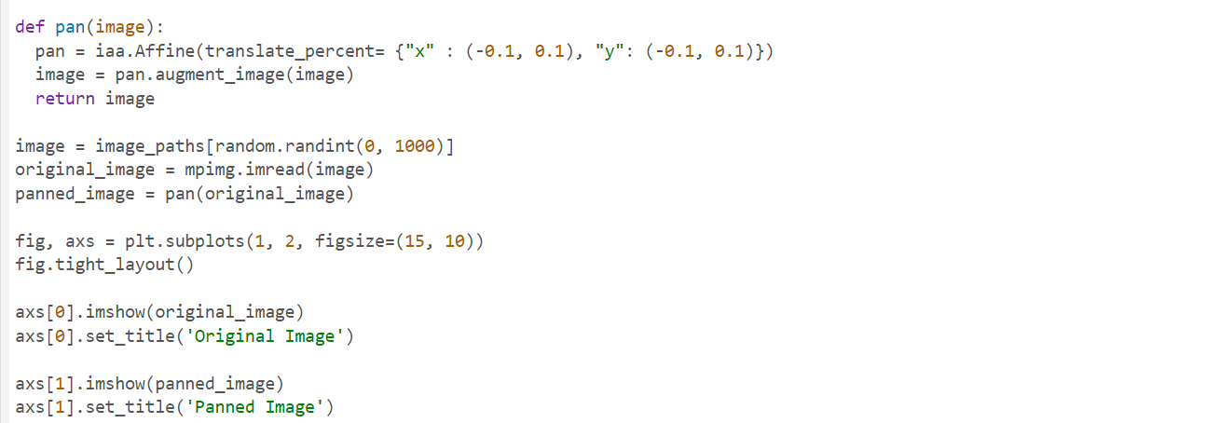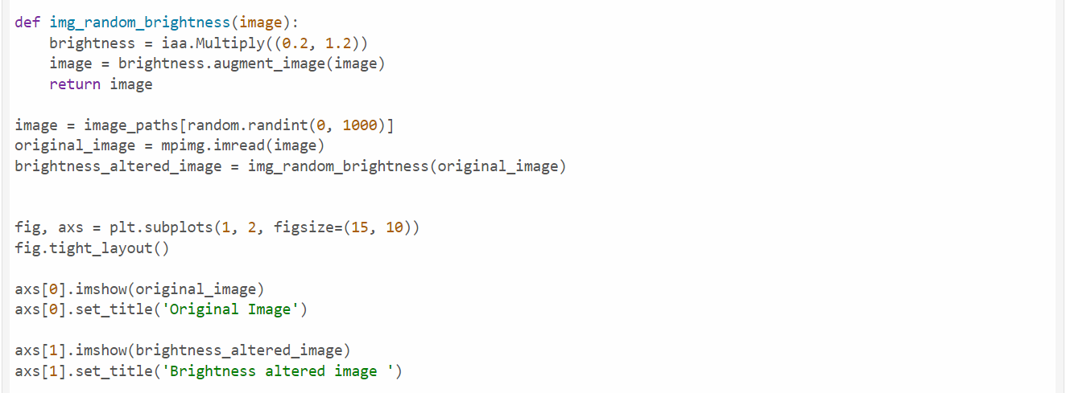

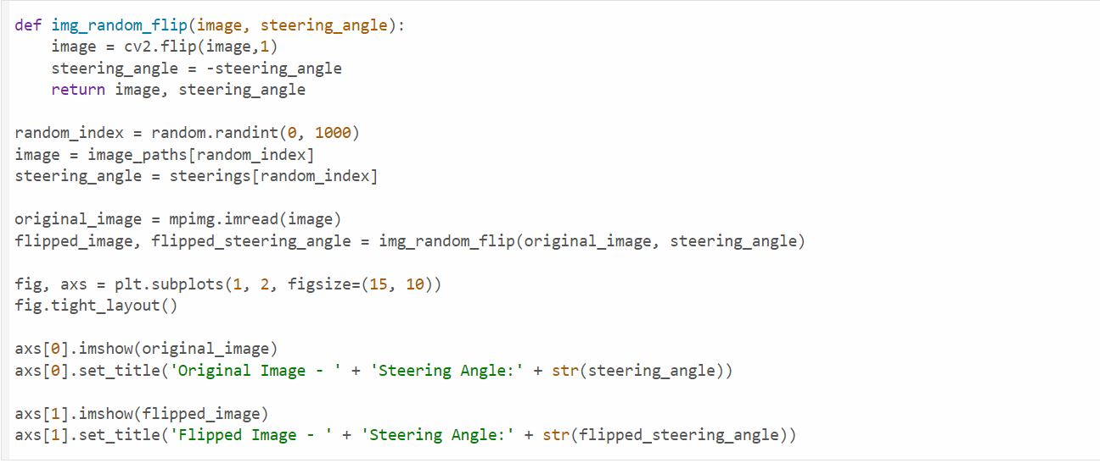 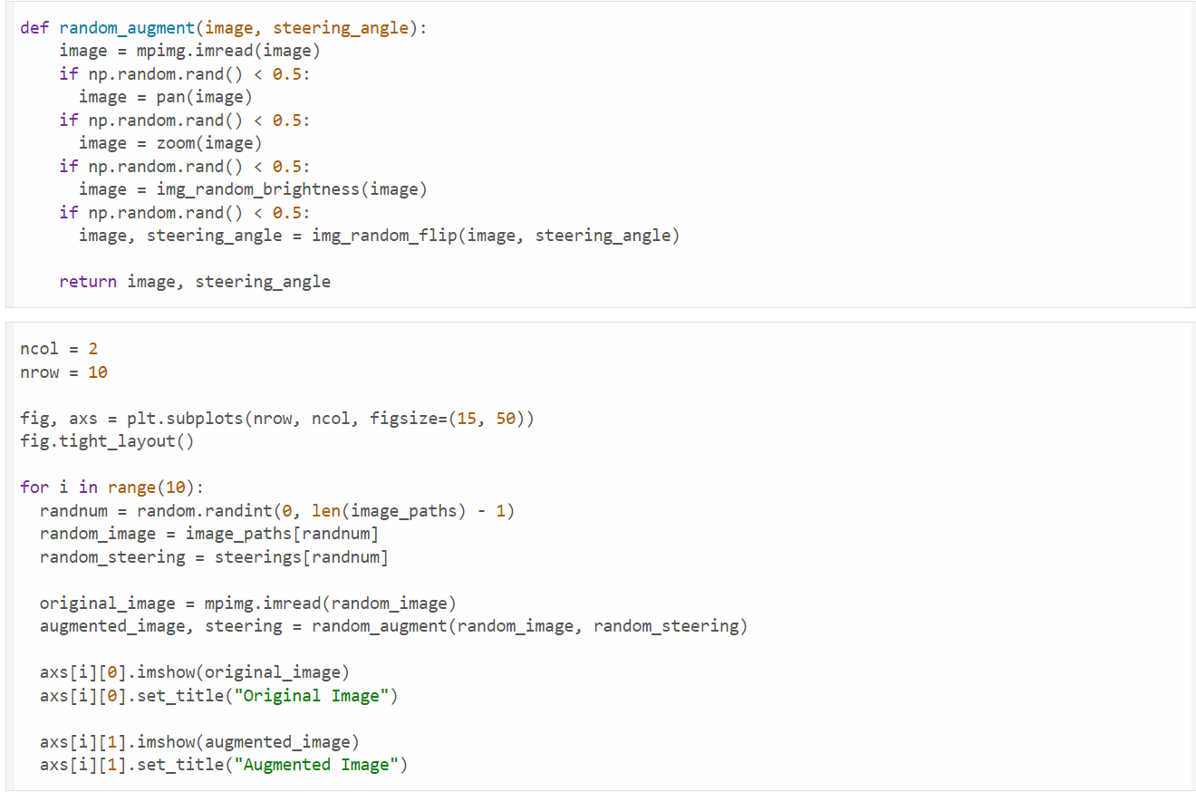 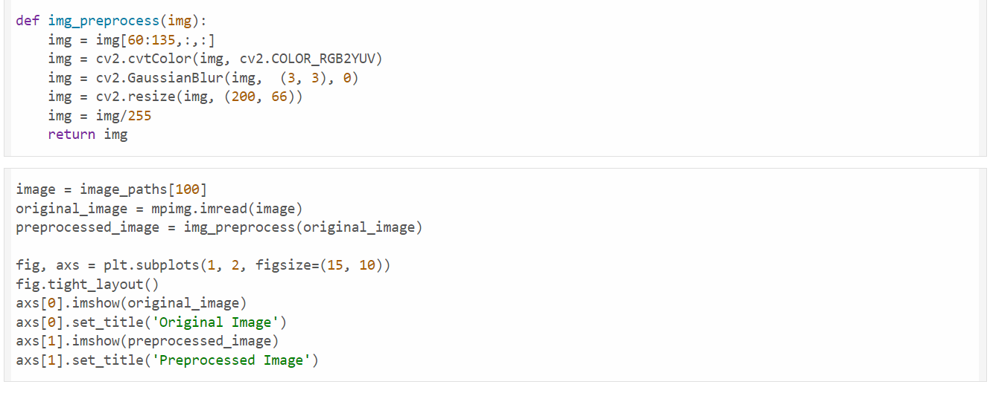

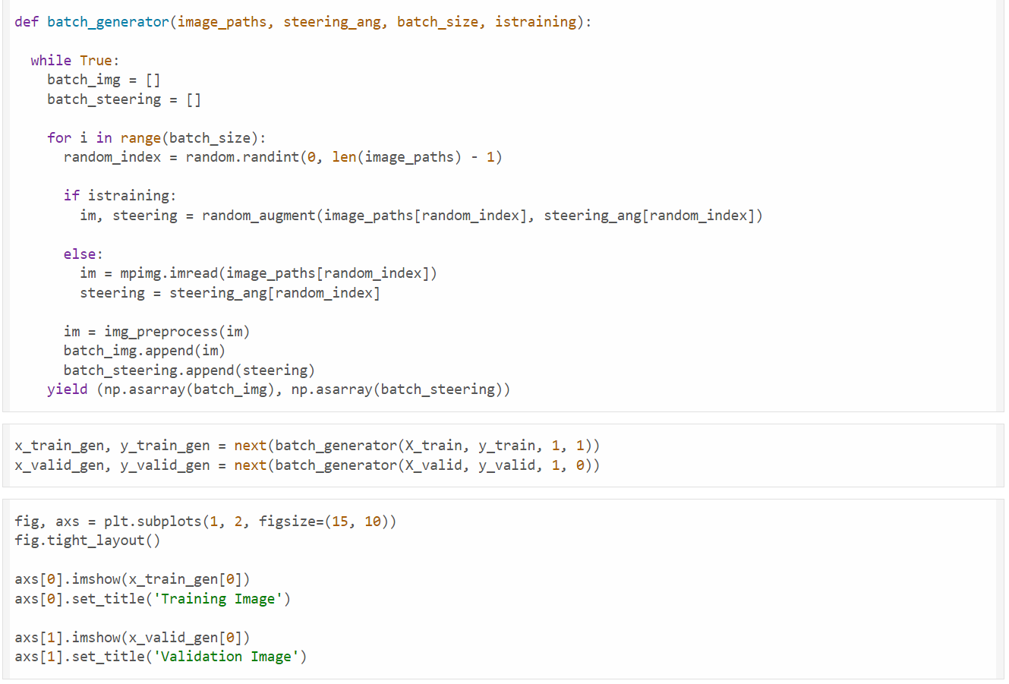

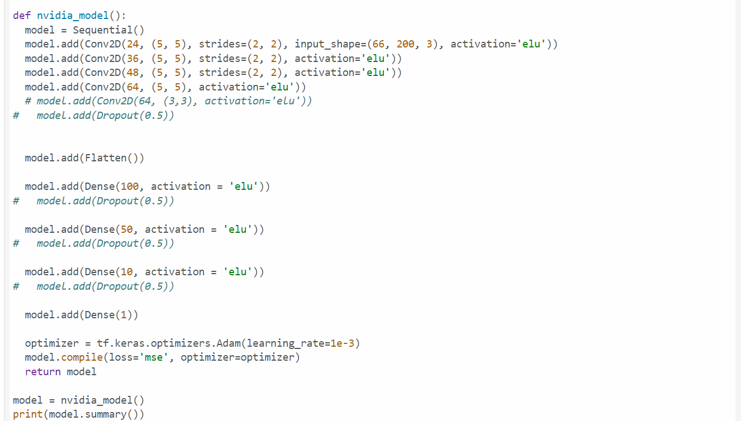 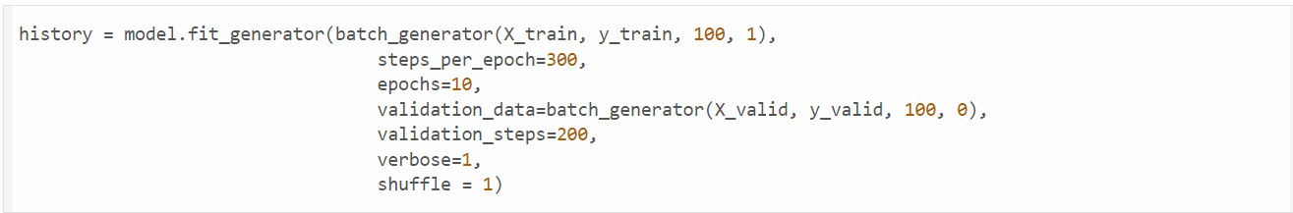 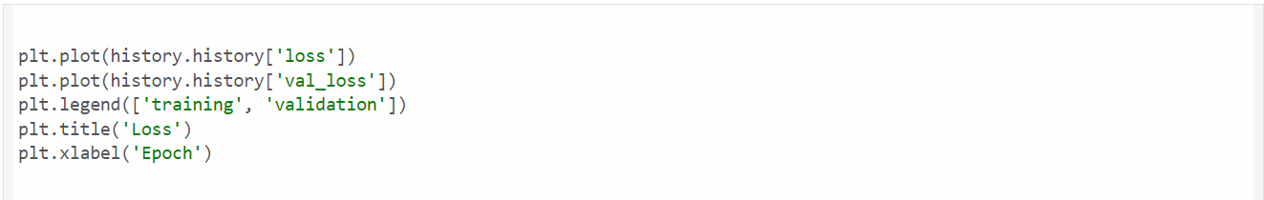 

**6. OUTPUT**

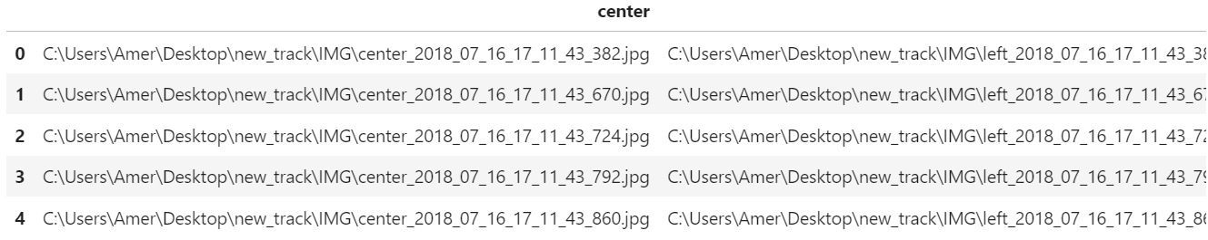

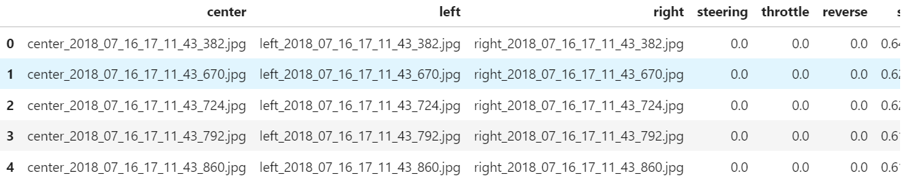

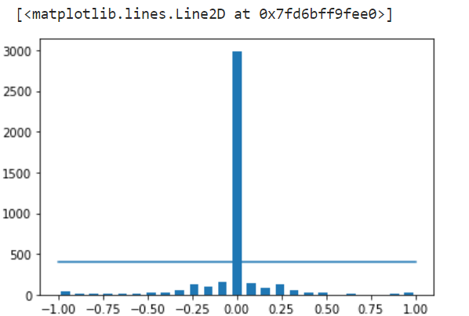

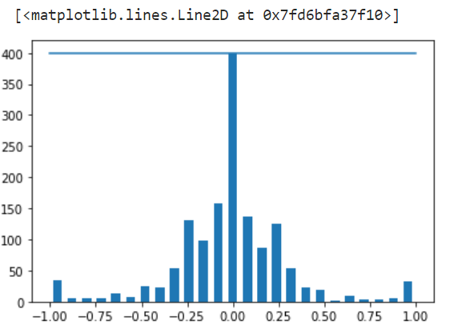

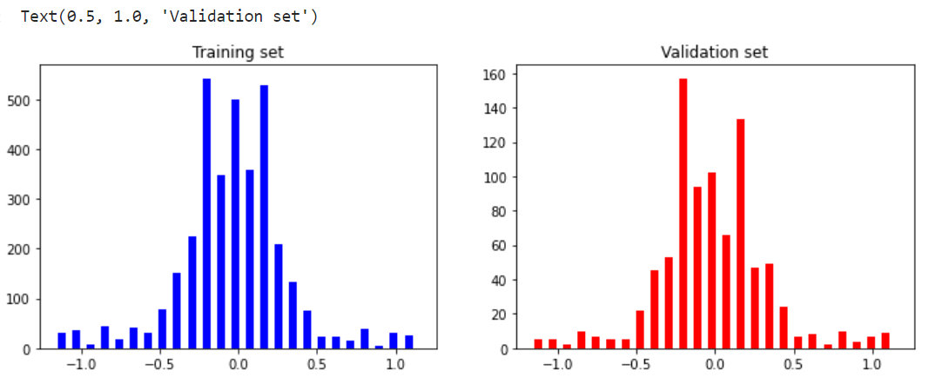

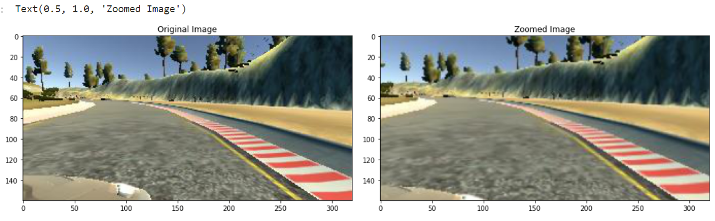

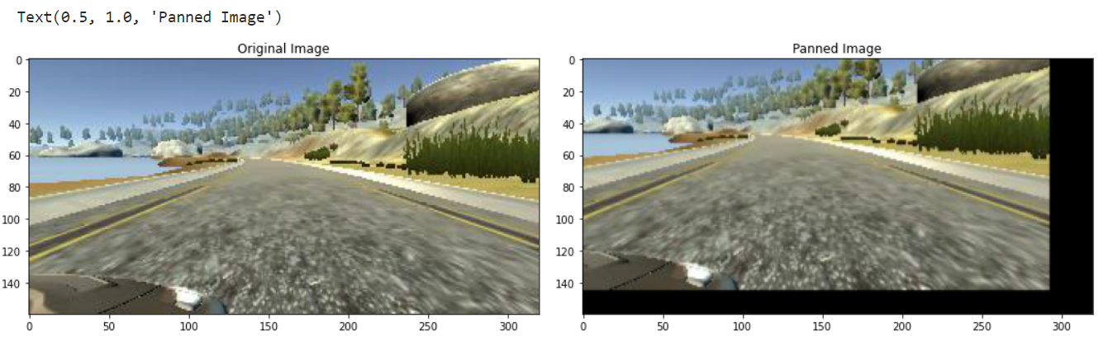

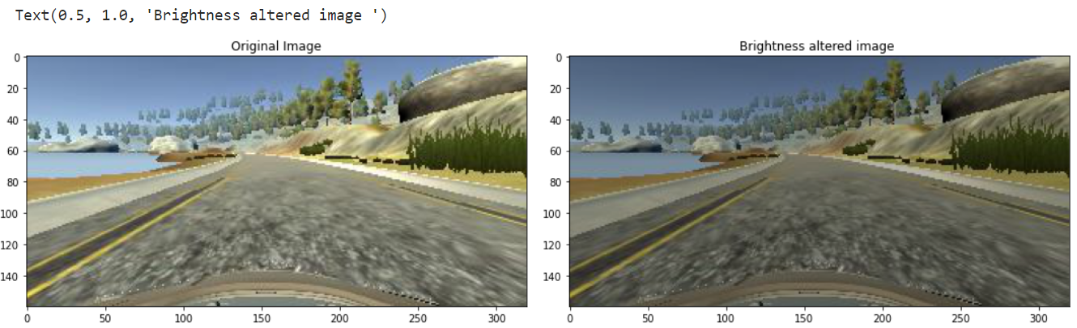

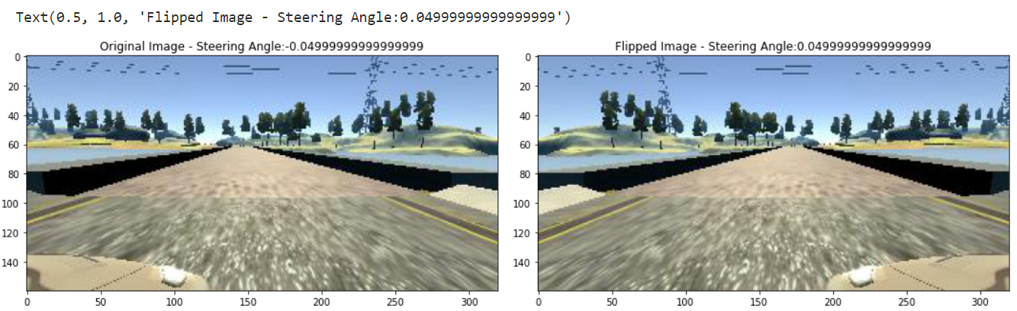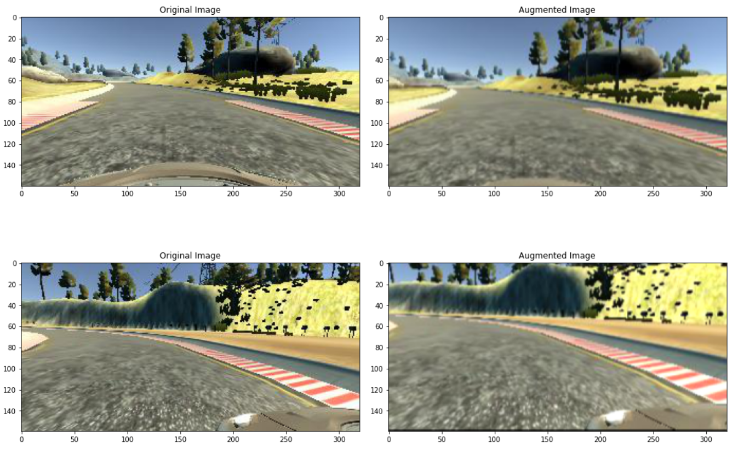

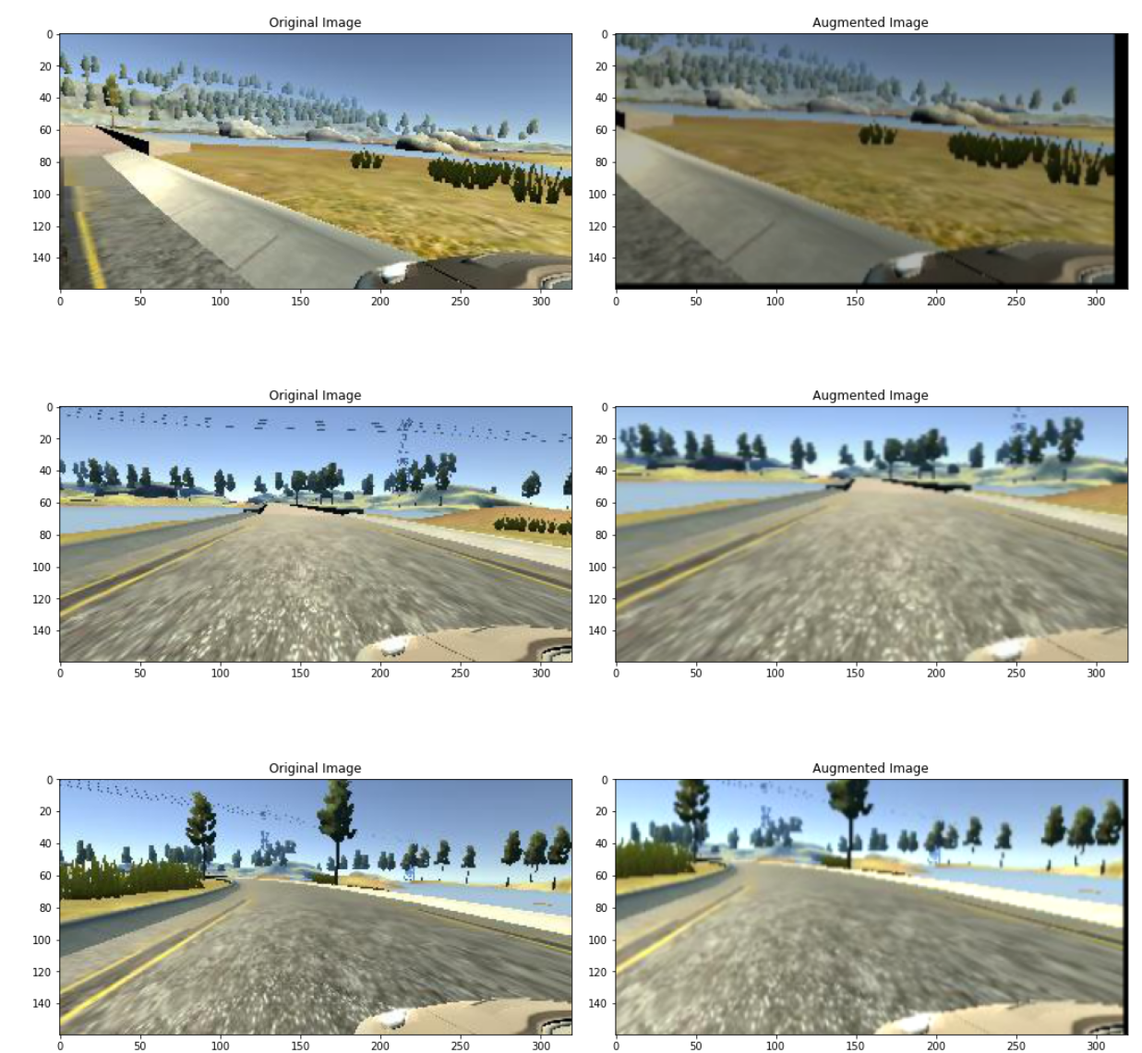 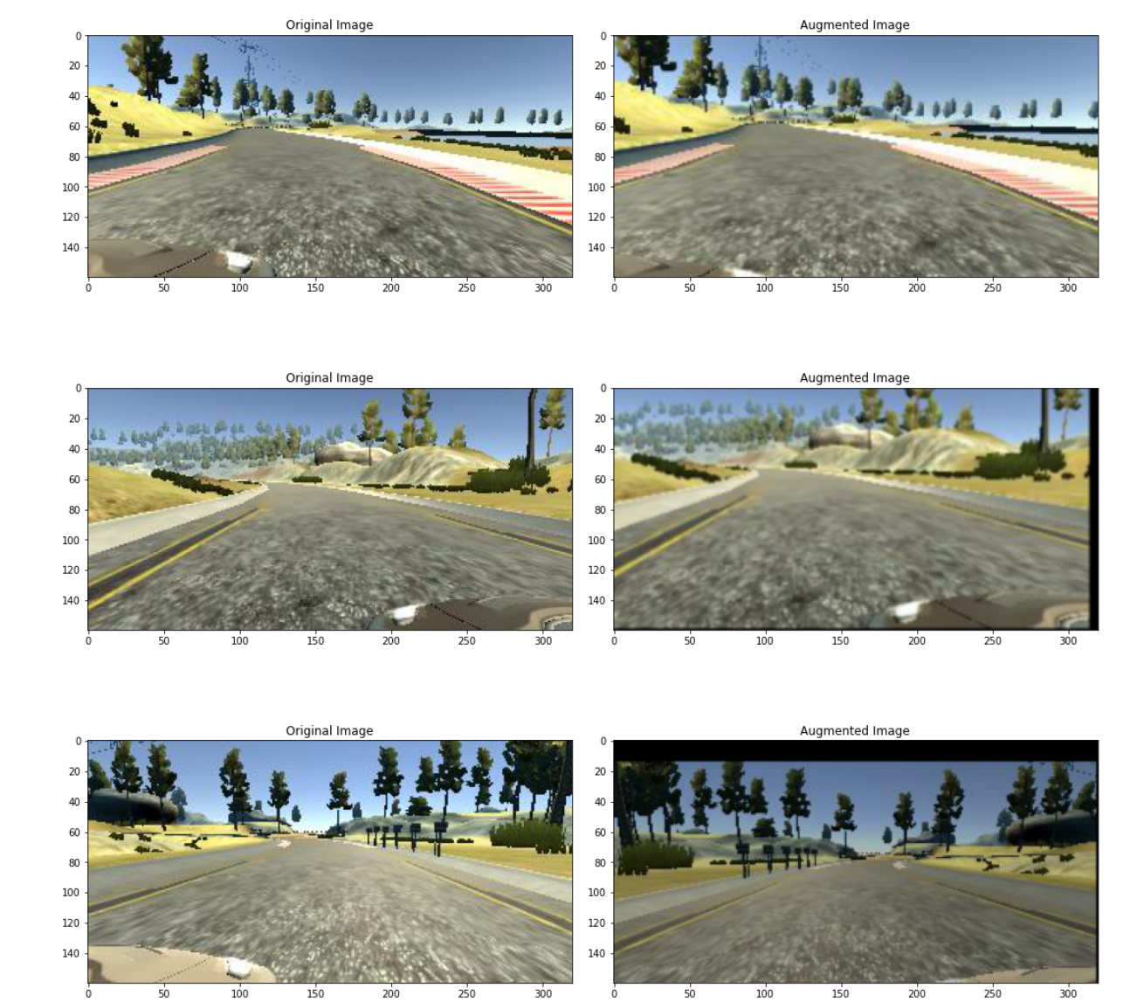 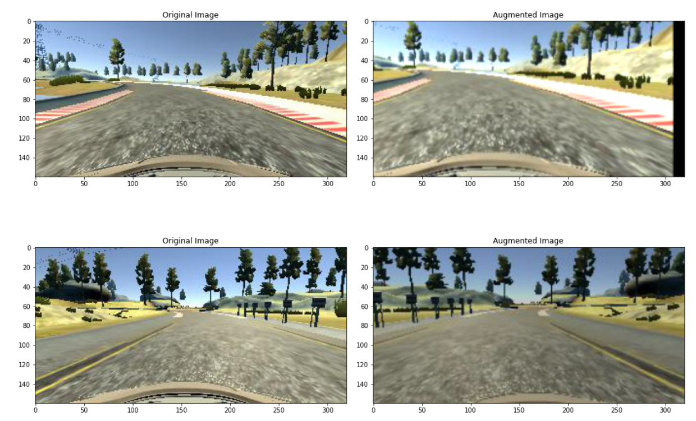 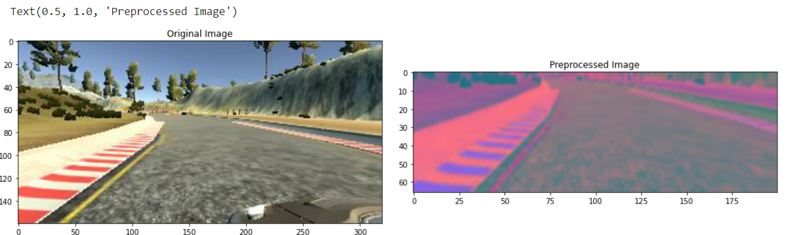 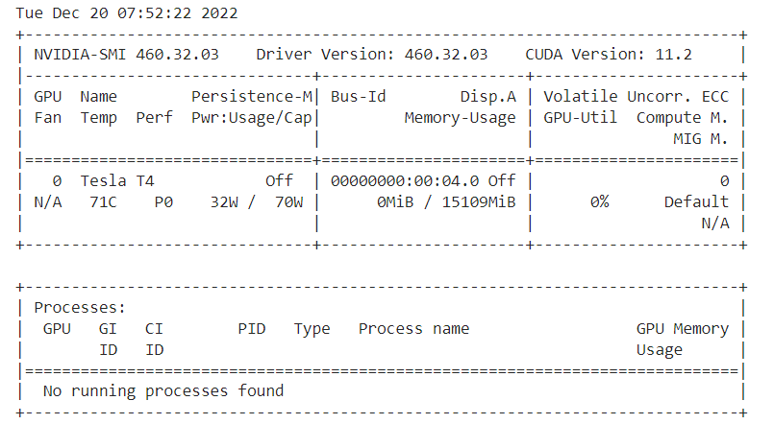 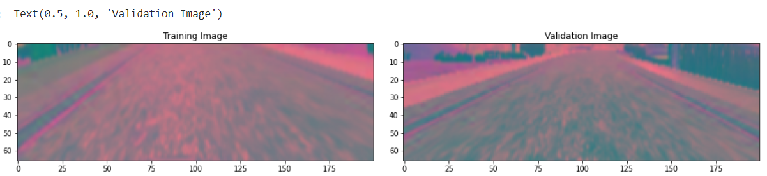 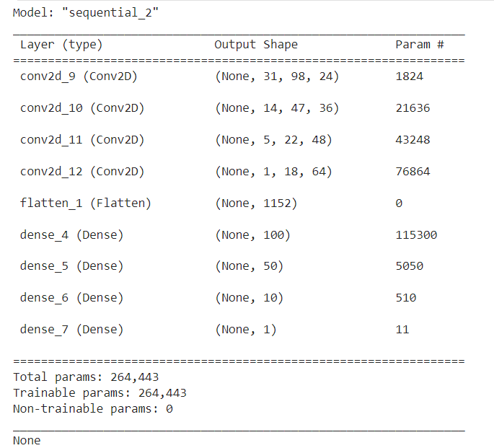 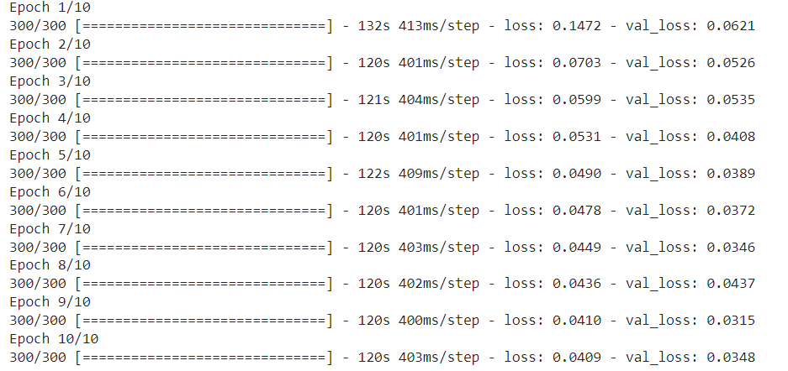 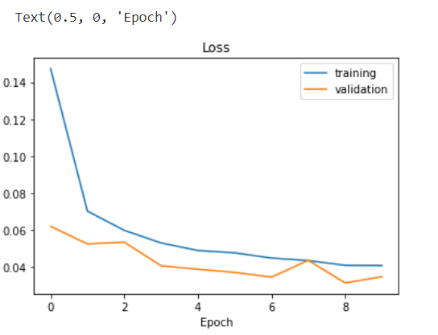

**7. Results:**

We know that processing power of raspberry pi is low as compared to other mobile processors. So, we set up a server client architecture for the prediction of deep learning model, in this case server has graphics processor which enhances speed of the algorithm.

If we consider Model I we were investing more time in lane detection which is not a primary concern as we trying to shift towards deep learning model. So, in this case Model II would be a better choice. But both of these models were somehow inconsistent in some cases which made us to think about Model

III.

Model III worked out pretty well as it was accurate on training dataset but there was a little lag as compared to open cv based implementation because we were making predictions on LAN server. This can be solved by integrating on device graphics process.

## 7.10 Result Analysis

Currently on the software side(simulation), almost all modules are implemented. Foreign object avoidance and lane following are working. The car will follow the lane lines and avoid any other vehicles / pedestrians and any other obstacles. It will also slow down on junctions, and overtake other vehicles, and execute emergency stops when other options are not available. On the hardware side, some issues are occurring due to insufficient compute power. The car is following lanes but some issues are occurring due to limitations of the hardware. The car will execute an emergency stop when the sensor detects any obstacles using the sensor. The backbone of this project is the LAN server because raspberry pi has insufficient computation power. Car drives automatically very well after training using a high-resolution dataset. Car stops whenever it finds a STOP sign or RED signal and if the ultrasonic sensor detects any object it will break and avoid collision.

## 8.1 Conclusion

For most cases, the given system works as expected. However, in some cases, it may cause false undesirable behaviour in some conditions. On the simulator side, the car works for the most part and executes the desired operations. All the subsystems are working perfectly fine without any guidance. However, on the hardware side, primarily due to hardware limitations and compute power issues, some lags and undesirable behaviour takes place. This is due to variable lighting conditions, quality, clarity issue of camera due to motion of car. Hence, it may be necessary to refine the model further depending on its use case in order to maximize accuracy. Also, better on-board computer power and high-speed wide-angle cameras may be required to enhance our system performance.

## 8.2 Future Work

* Deploy a system which perceives the information from surroundings and stores it which can be used for continuous improvement of car.
* Deploy more powerful sensors such as LIDAR, RADAR which enables us in tracking down objects more precisely.
* To increase interaction with surrounding environment we can add horns and different alering systems.
* In order to enhance security, we might need to develop a system that protects user’s privacy.
* To make an efficient real-time system which shows information about car’s surroundings, details of its own state and decision which it is taking based on perception. We believe that it is helpful for the person who is sitting inside the car as it increases transparency and trust factor.

# REFERENCES

1. Spyder. 2018. Spyder-The Scientific Python Development Environment. [https://www.spyderide.org](https://www.spyder-ide.org/)
2. Virtual Network Computing. March 2020.

<https://en.wikipedia.org/wiki/Virtual_Network_Computing>

1. Hyperlabel. 2020. HyperLabel- The fastest path to machine learning”. <https://hyperlabel.com/>
2. Android Studio. May 2020. <https://en.wikipedia.org/wiki/Android_Studio>
3. Android Studio. March 2020. Meet Android Studio. <https://developer.android.com/studio/intro>
4. Liu W. et al. (2016) SSD: Single Shot MultiBox Detector. In: Leibe B., Matas J., Sebe N., Welling M.(eds) Computer Vision – ECCV 2016. ECCV 2016. Lecture Notes in Computer Science, vol 9905.Springer, Cham
5. Jonathan Hui, “Real-time Object Detection with YOLO, YOLOv2 and now YOLOv3”

[Online]. Available: [Online]. Available: “https://medium.com/@jonathan_hui/real-timeobject-detection-with-yolo-yolov2-28b1b93e2088”

1. Ross Girshick, Jeff Donahue, Trevor Darrell, Jitendra Malik “Rich feature hierarchies for accurate object detection and semantic segmentation Tech report (v5)” 2014 IEEE Conference on Computer Vision and Pattern Recognition
2. Ross Girshick. “Fast R-CNN” 2015 IEEE International Conference on Computer Vision (ICCV)
3. Shaoqing Ren, Kaiming He, Ross Girshick, and Jian Sun “Faster R-CNN: Towards Real-Time

Object Detection with Region Proposal Networks” June 2015 IEEE Transactions on Pattern Analysis and Machine Intelligence